Greetings, Committees


and Events

5787/2026

Shanah Tovah U'm'tukah –

a good and sweet year Oseh!

Welcome Cantor Zoe!

May your sweet voice and music
grace our bimah for many years.


John Riehl

"If you believe that you can
damage, believe that you can fix.

If you believe that you can harm, believe that you can heal."

Rabbi Nachman of Breslov

L'shana tovah from
Brad Sachs and Karen Meckler

May this Rosh Hashanah bring peace
and the year ahead be filled with
happiness and good health.
L'Shanah Tovah!
Linda and Art Solomon

L’Shana Tovah, U’metukah!

A sweet and happy new year!
The Friedmans
Beth, Andy, Molly, Lee, and Stephanie

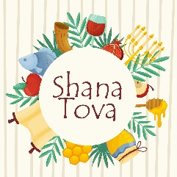
Shana Tova
Wishing all a sweet and
healthy new year.
Steve Kaplan & Lynne Gaynes-Kaplan

Best wishes for a
Healthy, Sweet and
Happy New Year!

Nancey and Steve Parker

May the coming year be filled with sweetness, joy, laughter and love.
Bonnie, Michael, Alana, Zac,
Susan, Julia and Jonah Cornell

May You Be Blessed with a Year
of Health and Happiness.
Diane and Ray Wacks

Wishing our Oseh Shalom family a healthy and joyous
New Year, and praying for peace in the world in 5787

The Salant Family –Sandy, Steve, Brian,
Katixa, Txeru, Miko, Enara, Maida,
Tommy, Peter, and Benny
Wishing everyone a year of joy, health and music.
Melody, Gary, Josh and Juli Magnus, Evan Moore and Elli Magnus Moore

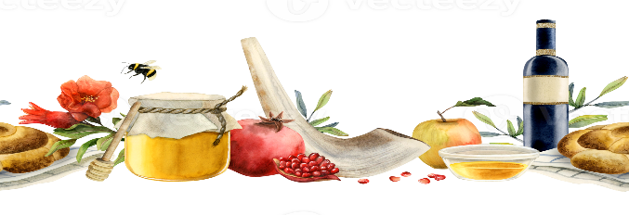

May you have peace and
joy in the New Year!
Robert and Margie
Ginsberg

May it Be a Sweet Year Filled with Renewal, Prosperity, Joy & Inspiration Happy 5787 – Shanah tova u’mtukah
- Rabbi Rebecca
Shanah Tovah

Wishing our family, friends, and the entire Oseh Shalom community a New Year filled with sweetness, good health, peace, and joy. May 5787 bring blessing, renewal, and meaningful moments together.

With warm wishes for a happy and sweet New Year,
Shelley & Adam Reese

- Wishing our Oseh family a joyous, healthy, and peaceful New Year. Rich & Sue Burger
- Have a sweet and healthy New Year! Bella Clamage
- L'Shanah Tova Tikateivu from Ernest & Elmina Hilsenrath
- Happy, Healthy & Sweet New Year! Cathy, Rob, Ben, Michele Weiss
- L’Shana Tovah 5787 from the Potemken-Friedman family!
- Wishing you a Sweet and Happy New Year! Claire & Curtis Menyuk

--------------------------------------

Learn about some of
Oseh Shalom’s Committees
and Upcoming Events…

Membership and Engagement

The Membership & Engagement Committee is committed to building our community, both by helping current members engage with others, and reaching out to new and prospective members. To help make our community everything it could possibly be, we would love for you (yes, you) to get your tuchus in the building more! Please consider coming to services, talking to people at an Oneg, or attending an event. And bring a friend! Being involved is not only a mitzvah, but it also provides an opportunity to connect with people and ideas.

Please Remember:
- Wear your name tags (found in the entrance hallway) when you come to Oseh. It’s a great way to meet new people and help those of us with terrible memories!
- Let Benj (our synagogue administrator) know if you are not receiving the weekly email or the bi-monthly print copy of the Shalom.
- Follow Oseh’s “Eleventh Commandment” and say hello to a stranger!
Things to Look Forward to This Year
- First day of Oseh Shalom Religious School year: September 27, 2026
- Rising Song Nigun Circle Shabbat with catered meal: October 30, 2026
- The Big Oseh Shalom 60th Birthday Gala: November 14, 2026
- Hanukkah Party: December 6, 2026
- Annual Retreat: January 15-17, 2027

And look out for:

- Prospective & New Member Brunch
- Volunteer Appreciation Service & Oneg
- Intimate Havdalah Dinners with fellow Oseh Shalom Members

Oseh Shalom welcomed the following
new members in 5786:

Andrés Ávalos
Samuel Brad and Ren Marmo
Michael Goldman, Shandra Goldfinger and Maxwell Gold
Jose Guzman
Kirk, Laura, Abraham and Solomon Halpin
Seth, Jennifer, Conor and Alexander Kandel
Angelo Klonowski
Jonathan, Christina, Abigail and Eleanor Mauro
Nate Orlowek

If you have questions or ideas for the Membership and Engagement Committee, please reach out to Aaron Clamage and Adam Richman by emailing membership@oseh-shalom.org.

-----------------------------------------------------------------------------
RDEI
Racial Diversity Equity & Inclusion

Oseh Shalom strives to welcomes members and guests of all racial, ethnic, age and gender identities as well as those with special needs, such as mobility, diet or movement. We have an active Racial Diversity, Equity and Inclusion Team team that is working to make us more welcoming by breaking down barriers and offering education. Let us know if there are ways we can be more inclusive.

We strongly welcome new voices on our team. For information about the RDEI group, contact Marcia Dresner or Melody Magnus.
Sacred Grounds

Save the Date: Native Garden Dedication Event

Mark your calendars for October 4, 10:30 am, to join the Sacred Grounds Team, OSRS students and staff, clergy, and invited dignitaries, at the dedication of the large native garden that was installed to the right of the religious school wing last fall. The event will include brief remarks and benediction, music, a related art activity for the children, and, of course, a nosh!! To assist with our planning efforts, please complete the registration form (https://osehshalom.shulcloud.com/form/Sacred-Grounds-Dedication-2026.html) to let us know you are coming.

The installation of the garden was a massive volunteer effort, funded by a grant from the National Wildlife Federation (NWF). We hope you have observed the garden and have seen its progress as it’s grown from little plugs to flowering plants. A small, dedicated group of Oseh Shalom members have been working diligently through the summer to water and weed the garden. HUGE shout out and thank you to Jose Guzman, Heidi Hess-Webber, Judy Katz, and Melody Magnus for their commitment to keeping our garden thriving!

We’d love to have YOU join our efforts in maintaining the many gardens on the Oseh Shalom property. Reach out to us at sacred.grounds@oseh-shalom.org.

B’Shalom,
Sue Burger & Linda Solomon
Sacred Grounds Co-Chairs

Men’s Club

Come join the Men’s Club as we support Oseh Shalom‬ through a variety of activities, including but not limited‬‬ to:‬‬‬‬‬‬‬‬‬‬‬‬‬‬
‬‬‬‬‬‬‬
• ‬High Holiday Gift Baskets‬‬‬‬‬‬‬
• Sukkot Building‬‬
• H‬anukkah Set-up‬‬‬‬‬‬‬‬‬‬‬‬
• Super Bowl Party
• Passover Wine Sale‬‬
• BBQ & Barchu‬‬
• Brunches with speakers‬‬
• Field Trips to interesting places‬
• ‬Sports Teams‬‬
• Road Clean-up‬‬
• Oseh Garden Maintenance‬‬
‬‬‬‬‬‬
Look at the Oseh Shalom website Calendar (www.oseh-shalom.org/calendar), ShulCloud and the weekly eNews for details on‬‬ these and other upcoming activities.‬‬ For more information, contact Matt Baker at‬ rekabmh@gmail.‬‬‬‬‬‬‬‬‬

-----------------------------------------------------

Sisterhood Hanukkah Gift Shop Sale

Sunday, November 15th from 9:00 am – 12:00 pm

Also back by popular demand: Name your price table! Bring your Judaica items you no longer need to donate for others to buy. All items on this table will be “see an item you like and offer a price”.
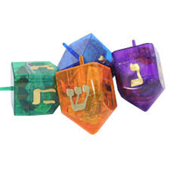


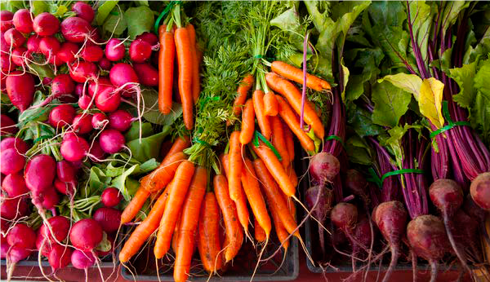
Oseh Shalom’s Annual
Farm-to-Sukkah Dinner
Saturday, October 3, 2026
Wine and Hors d'oeuvres to begin at 6:00 pm
Followed by Havdallah and Dinner
Guests will experience delicious and locally sourced wine and fine food in our beautiful Sukkah. $40.00 per person or $300.00 per table of 8 - includes full meal, wine and a remarkable learning experience.
Space is limited; sign up online early in ShulCloud! Find the link on the Oseh ShulCloud page.
---------------------------------------------------
Rosh Chodesh

Oseh’s Rosh Chodesh is a warm, smart and friendly group of women who meet regularly to explore Judaism through a woman’s perspective. Meeting topics range from cooking classes to topical issues, cultural norms and book discussions. We usually have one field trip a year to an area museum. Each spring we hold a unique seder focusing on the role of women.

Meetings are Sundays at 2:00 pm at member homes or at Oseh Shalom. All women and those who identify as female are welcome.

Contact melmagnus25@gmail.com to join our email list or contact Marla Singer at moosewonk@gmail.com for any other information. Come and join us….
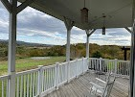
SAVE THE DATE for RETREAT 5787
January 15-17, 2027

This year’s Retreat will again be held during Martin Luther King Weekend (January 15-17, 2027) at the Claggett Center in Adamstown, MD. Please mark your calendars and join us! The Claggett Center is located at 3035 Buckeystown Pike in Adamstown, Maryland. Details will be coming in the weeks ahead.

---------------------------------
Oseh Shalom’s Annual Camping Shabbaton
Friday, May 14-16, 2027
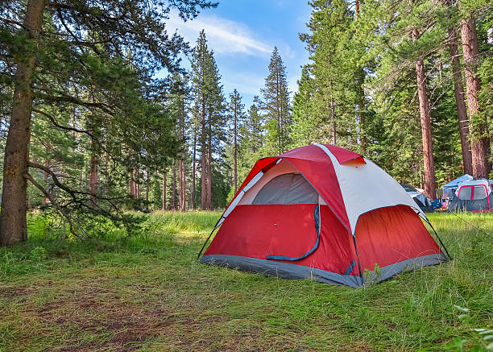
Join us for a wonderful Shabbaton where you’ll have time for music, walks, bird watching, stargazing, wood carving (even if just for marshmallow sticks), Havdalah, prayer, and yoga/TaiChi. We will share our knowledge and have fun while we learn some new skills, new ways of looking into our surroundings and even something new about ourselves. Let this weekend camping event offer the opportunity for a stretch towards a stronger connection to nature, Judaic values, and community.
Does the program look good but you are not a camper? Come up for the day Saturday and share the spirit and fun. Swim and hike and enjoy the outdoors with a Jewish twist.
Questions? Contact: camping@oseh-shalom.org, or call Marc Litz at (443) 832-5898.
Social Justice

"Tzedek, tzedek tirdof - justice, justice shall you seek." Interested in getting involved with Social Justice at Oseh? We are always looking for new members of the Social Justice committee. We work on education and advocacy initiatives to promote causes such as economic justice, immigration justice, environmental justice, and reproductive justice.

In the past, we've done programs that included tabling at a local Pride festival, watching a documentary on the prison system, and organizing educational programs such as Labor on the Bimah and what's at stake in local elections, among other topics. Our Social Justice listserv, open to all interested synagogue members, is also an avenue to share volunteer opportunities and events from partners such as Jews United For Justice (JUFJ) and Bend the Arc.

Interested in programs like these or have other ideas for programs you'd like to see, or want to join the Social Justice listserv? Message socialjustice@oseh-shalom.org for more information or to join. And stay tuned to the Oseh e-news for social justice meetings and volunteer opportunities.

On behalf of the Social Justice Committee, may you have a sweet, happy, and healthy new year!

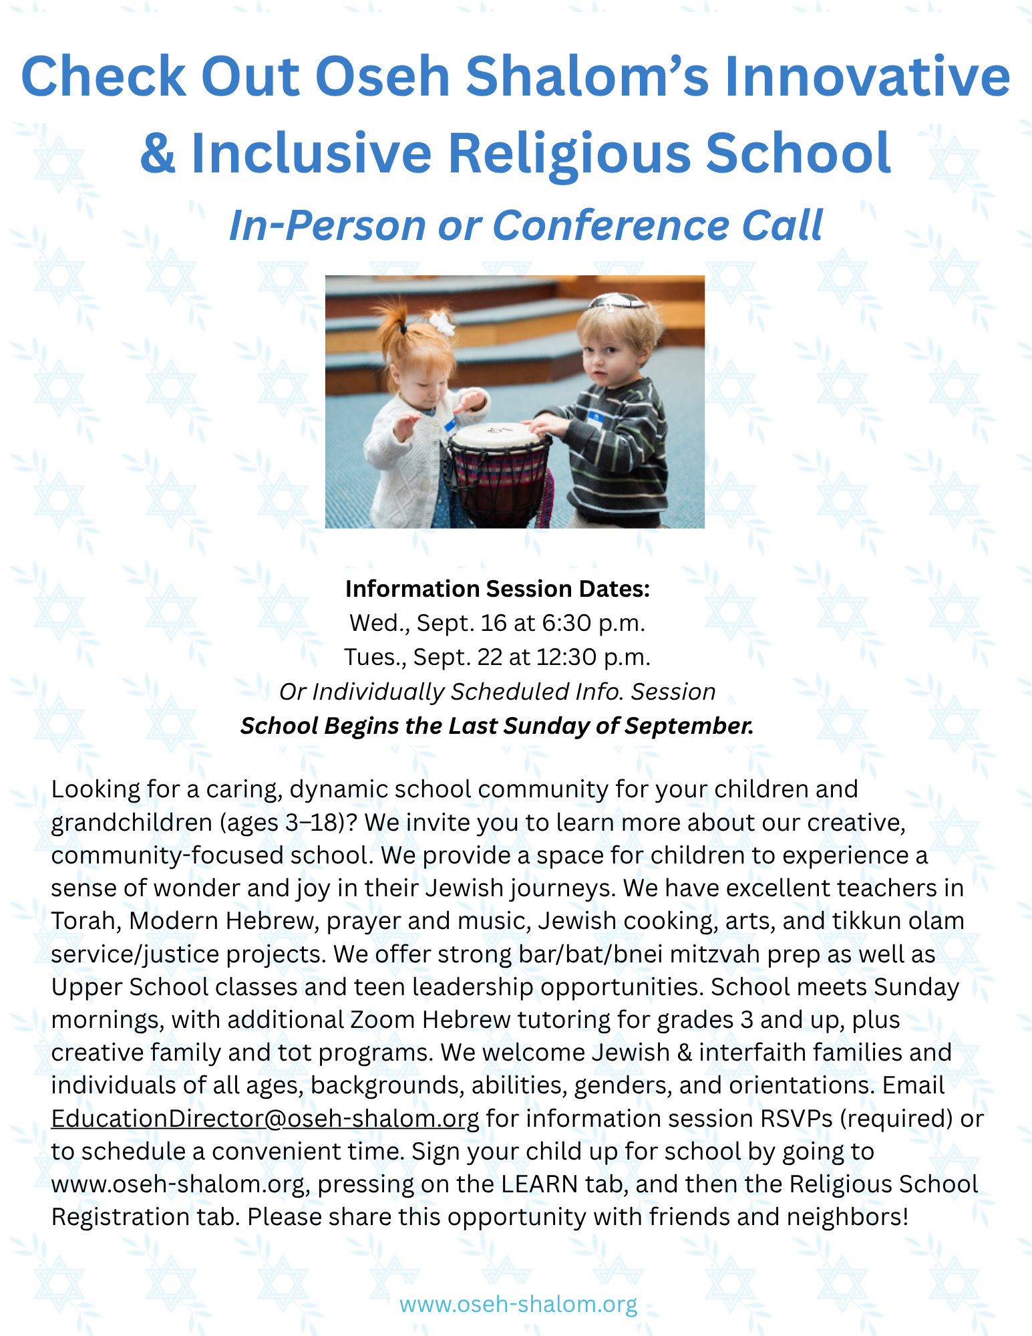

Oseh Shalom
7515 Olive Branch Way
Laurel, MD 20725

301-498-5151
www.oseh-shalom.org

