HOWARD COUNTY JEWISH COMMUNITY BOWLING LEAGUE
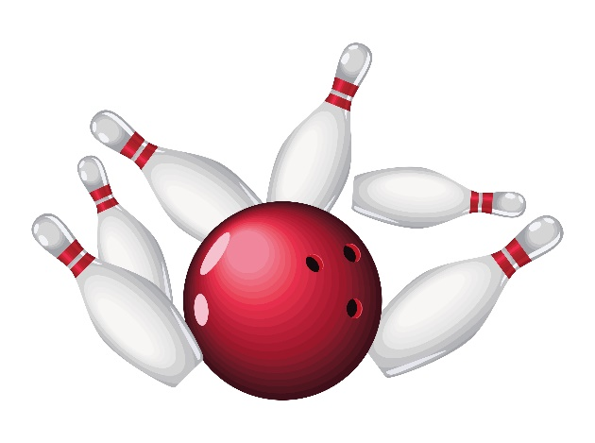
Do you remember how much fun you had as a kid doing ten pin bowling? Want to relive those experiences and meet other fun people? Join us at Bowlero in Columbia one Sunday morning a month at
10:00 am (with practice at 9:45 am):

September 7; October 19; November 9; December 14;
January 11; February 15; March 22; April 19; and May 17;
followed by an after-season dinner in June.

Teams of four, but you can join as an individual, couple, or four-some. If you miss a day, you can pre-bowl ahead of time AND members of the League are able to practice bowl once every week – two games a week!! You need to rent or provide your own bowling shoes.
We are waiting to hear monthly costs from Bowlero. (Last year was $21, which included the end-of-season dinner.)
If interested or for further information, contact:
Sharon Freedman, at safreedman@comcast.net or 410-599-6889
or Steve Bloom, at sdbloom89@gmail.com or 443-520-8489

