An Introduction to the High Holy Days:
View the film:
Spiritual Audacity: The Abraham Joshua Heschel Story,
Followed by The Slichot Service
Saturday,August 28 7:30 pm
In Person and on Zoom

Slichot is the gateway to the High Holy Days. It is the short service that introduces us and prepares us for the spiritual effort that will take place over the next number of weeks stretching from Rosh Hashannah to Simchat Torah.

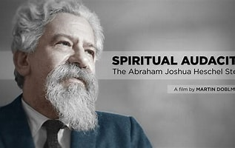

Join Rabbi Josh as we view the film, celebrate Havdallah and discuss the film. Martin Doblmeier has produced a new documentary on the life of famous twentieth century Rabbi Abraham Joshua Heschel. The film, SPIRITUAL AUDACITY: The Abraham Joshua Heschel Story, takes a closer look at Heschel’s life and achievements.

After the film there will be a discussion of the film and the life and impace of Heschel. The Slichot Service will begin about 9:45.

