Mondays, October 12 - December 14
7:30 – 9:00 PM Via Zoom
$295 for ten weeks, includes coursebook

Within the field of ethics, one of the most challenging frontiers is medical ethics. While contemporary medical knowledge preserves life, modern advances have raised moral and ethical dilemmas related to the sanctity and dignity of life—issues whose scope was unimaginable a generation ago. Written by Rabbi Elliot Dorff, PhD, Jewish Medical Ethics explores Jewish approaches to a number of 21st-century ethical issues, including human cloning, surrogate motherhood, genetic identity, assisted suicide, and genetic manipulation.
Ten Topics, ten weeks:

- Cloning of Plants, Animals, and Humans
- Prenatal Interventions and the Termination of Pregnancy
- Surrogate Motherhood and Multiple Parents
- Sperm Banking and Posthumous Sperm Retrieval
- Genetic Identity
- Gene Testing
- Pain Management and Drug Addiction
- Passive Euthanasia: Heroic Efforts vs. Letting Nature Take Its Course
- Assisted Suicide/Aid in Dying
- The Distribution of Health Care: Who Gets it? Who Pays for it?

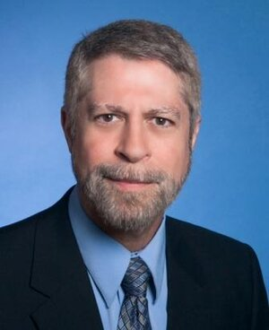

Rabbi Dr. Gary Fink is a pastoral counselor who specializes in grief, loss, and life-limiting illness. He leads the Montgomery Hospice chaplaincy staff, oversees the volunteer program, and provides community education in end-of-life care and counseling. He is also an adjunct faculty in the Psychology/Thanatology Graduate Program at Hood College in Frederick, MD. He is Rabbi Emeritus at Oseh Shalom in Laurel, MD where he served as congregational rabbi for over 25 years.

Register on-line below through the Melton events website https://www.events.org/creg.aspx?e=135810&m=10. Scroll through the list to select this course. To register by check and for more information, contact Val Kaplan at vkaplan66@verizon.net. The Zoom link will be sent to all registrants prior to the first session.

REGISTER

