YOM KIPPUR: MEDITATION SERVICE 5781

HEAVEN-EARTH MEDITATION

INVITING OUR FUTURE SELVES: HODIYEINI YAH R’ Shefa Gold

Hodi’eini Yah kitzi, u’midat yamai ma hi

Oh God, show me my end, and what is the measure of my days?
(Psalm 39:5)

UNIFYING THE HEART: V’YACHAYD L’VAVAYNU R’ Shefa Gold
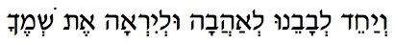
V’yachayd l’vavaynu l’ahavah u’l’yirah et sh’mecha.
Unify our hearts to love and to be in awe of Your Name/Essence. (From the Liturgy)

KUMI LACH: R’ Shefa Gold
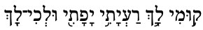
Kumi Lach rayati yafati, u’l’chi lach
Arise my friend, oh beautiful one,
go to yourself… (Song of Songs 2:10)

